Project name:

Flappy bird

Group Members:

1. Irfan Ahmed

2. Quaiumuzzaman Pasha

Code:

#include "igraphics.h"

int x=100,y=256;

int dy=5;

int aa=0;

int scr=0;

int over=0;

int play=0;

char str[8];

int p1x=340,p1y=390;

int p2x=340,p2y=0;

int p3x=600,p3y=270;

int p4x=600,p4y=0;

int p5x=900,p5y=0;

int p6x=900,p6y=350;

int p7x=1150,p7y=0;

int p8x=1150,p8y=200;

int r1x=356,r1y=390;

int r2x=356,r2y=0;

int r3x=700,r3y=270;

int r4x=700,r4y=0;

int r5x=1000,r5y=0;

int r6x=1000,r6y=350;

int tx=1200,ty=240;

void iDraw()

{

iClear();

if(play==0)

{

iShowBMP(0,0,"start.bmp");

iShowBMP(800,80,"play.bmp");

iShowBMP(280,100,"exit.bmp");

}

if(play==1)

{

iShowBMP(0,0,"start.bmp");

iShowBMP(100,270,"easy.bmp");

iShowBMP(100,170,"medium.bmp");

iShowBMP(100,70,"hard.bmp");

}

if(play==2)

{

iShowBMP(0,0,"background4.bmp");

iSetColor(255,255,80);

iFilledRectangle(r1x,r1y,35,162);

iFilledRectangle(r2x,r2y,35,300);

iSetColor(0,100,255);

iFilledRectangle(r3x,r3y,35,242);

iFilledRectangle(r4x,r4y,35,180);

iSetColor(0,255,100);

iFilledRectangle(r5x,r5y,35,260);

iFilledRectangle(r6x,r6y,35,170);

iSetColor(255,255,255);

iText(900,480,"SCORE:", GLUT_BITMAP_TIMES_ROMAN_24);

iText(990,480,str,GLUT_BITMAP_TIMES_ROMAN_24);

iShowBMP(x,y,"bird2.bmp");

iShowBMP(10,462,"arrow.bmp");

if( x+36>=r2x && x+40<=r2x+35 && y<=300 ||

x>=r2x && x<=r2x+30 && y<=300 ||

x+36>=r1x && x+36<=r1x+35 && y+36>=r1y ||

x>=r1x && x<=r1x+35 && y+36>=r1y ||

x+40>=r4x && x+36<=r4x+35 && y<=180 ||

x>=r4x && x<=r4x+35 && y<=180 ||

x+40>=r3x && x+36<=r3x+35 && y+36>=r3y ||

x>=r3x && x<=r3x+30 && y+36>=r3y ||

x+40>=r5x && x+36<=r5x+35 && y<=262 ||

x>=r5x && x<=r5x+30 && y<=262 ||

x+40>=r6x && x+36<=r6x+35 && y+36>=r6y ||

x>=r6x && x<=r6x+35 && y+36>=r6y || y==0)

{

play=5;

}

}

if(play==3)

{

iShowBMP(0,0,"background7.bmp");

iSetColor(255,255,80);

iFilledRectangle(p1x,p1y,35,162);

iFilledRectangle(p2x,p2y,35,300);

iSetColor(0,100,255);

iFilledRectangle(p3x,p3y,35,242);

iFilledRectangle(p4x,p4y,35,170);

iSetColor(0,255,100);

iFilledRectangle(p5x,p5y,35,260);

iFilledRectangle(p6x,p6y,35,170);

iSetColor(200,0,100);

iFilledRectangle(p7x,p7y,35,110);

iFilledRectangle(p8x,p8y,35,370);

iSetColor(255,255,255);

iText(900,480,"SCORE:", GLUT_BITMAP_TIMES_ROMAN_24);

iText(990,480,str,GLUT_BITMAP_TIMES_ROMAN_24);

iShowBMP(x,y,"bird6.bmp");

iShowBMP(10,462,"arrow.bmp");

}

if( x+36>=p2x && x+40<=p2x+35 && y<=300 ||

x>=p2x && x<=p2x+30 && y<=300 ||

x+36>=p1x && x+36<=p1x+35 && y+36>=p1y ||

x>=p1x && x<=p1x+35 && y+36>=p1y ||

x+36>=p4x && x+36<=p4x+35 && y<=170 ||

x>=p4x && x<=p4x+35 && y<=170 ||

x+36>=p3x && x+36<=p3x+35 && y+36>=p3y ||

x>=p3x && x<=p3x+35 && y+36>=p3y ||

x+36>=p5x && x+36<=p5x+35 && y<=260 ||

x>=p5x && x<=p5x+35 && y<=260 ||

x+36>=p6x && x+36<=p6x+35 && y+36>=p6y ||

x>=p6x && x<=p6x+35 && y+36>=p6y ||

x+36>=p7x && x+36<=p7x+35 && y+36<=110 ||

x>=p7x && x<=p7x+35 && y<=110||

x+36>=p8x && x+36<=p8x+35 && y+36>=p8y||

x>=p8x && x<=p8x+35 && y+36>=p8y||y==0)

{

play=6;

}

if(play==4)

{

iShowBMP(0,0,"background8.bmp");

iSetColor(255,255,80);

iFilledRectangle(p1x,p1y,35,162);

iFilledRectangle(p2x,p2y,35,300);

iSetColor(0,100,255);

iFilledRectangle(p3x,p3y,35,242);

iFilledRectangle(p4x,p4y,35,170);

iSetColor(0,255,100);

iFilledRectangle(p5x,p5y,35,260);

iFilledRectangle(p6x,p6y,35,170);

iSetColor(200,0,100);

iFilledRectangle(p7x,p7y,35,110);

iFilledRectangle(p8x,p8y,35,370);

iSetColor(255,255,255);

iText(900,480,"SCORE:", GLUT_BITMAP_TIMES_ROMAN_24);

iText(990,480,str,GLUT_BITMAP_TIMES_ROMAN_24);

iShowBMP(x,y,"bird.bmp");

iShowBMP(10,462,"arrow.bmp");

iShowBMP(tx,ty,"teer.bmp");

if( x+36>=p2x && x+36<=p2x+35 && y<=300 ||

x>=p2x && x<=p2x+30 && y<=300 ||

x+36>=p1x && x+36<=p1x+35 && y+36>=p1y ||

x>=p1x && x<=p1x+35 && y+36>=p1y ||

x+36>=p4x && x+36<=p4x+35 && y<=150 ||

x>=p4x && x<=p4x+35 && y<=150 ||

x+36>=p3x && x+36<=p3x+35 && y+36>=p3y ||

x>=p3x && x<=p3x+35 && y+36>=p3y ||

x+36>=p5x && x+36<=p5x+35 && y<=260 ||

x>=p5x && x<=p5x+35 && y<=260 ||

x+36>=p6x && x+36<=p6x+35 && y+36>=p6y ||

x>=p6x && x<=p6x+35 && y+36>=p6y ||

x+36>=p7x && x+36<=p7x+35 && y+36<=110 ||

x>=p7x && x<=p7x+35 && y<=110||

x+36>=p8x && x+36<=p8x+35 && y+36>=p8y||

x>=p8x && x<=p8x+35 && y+36>=p8y||

x+36>=tx && y>=208 && y<=240 || y==0)

{

play=7;

}

}

if(play==5||play==6||play==7)

{

iShowBMP(0,0,"dead.bmp");

iShowBMP(608,100,"try again.bmp");

iShowBMP(280,100,"exit.bmp");

iSetColor(255,255,255);

iText(580,400,str,GLUT_BITMAP_TIMES_ROMAN_24);

iText(412,400,"YOUR SCORE:", GLUT_BITMAP_TIMES_ROMAN_24);

}

//place your drawing codes here

}

void birdfall()

{

if(play==2||play==3||play==4)

{

y-=dy;

}

}

void pillermove()

{

if(play==2)

{

r1x-=5;

r2x-=5;

r3x-=5;

r4x-=5;

r5x-=5;

r6x-=5;

if(r1x<=0)

{

r1x=1024;

}

if(r2x<=0)

{

r2x=1024;

}

if(r3x<=0)

{

r3x=1024;

}

if(r4x<=0)

{

r4x=1024;

}

if(r5x<=0)

{

r5x=1024;

}

if(r6x<=0)

{

r6x=1024;

}

}

if(play==3)

{

p1x-=5;

p2x-=5;

p3x-=5;

p4x-=5;

p5x-=5;

p6x-=5;

p7x-=5;

p8x-=5;

if(p1x<=0)

{

p1x=1024;

}

if(p2x<=0)

{

p2x=1024;

}

if(p3x<=0)

{

p3x=1024;

}

if(p4x<=0)

{

p4x=1024;

}

if(p5x<=0)

{

p5x=1024;

}

if(p6x<=0)

{

p6x=1024;

}

if(p7x<=0)

{

p7x=1024;

}

if(p8x<=0)

{

p8x=1024;

}

}

if(play==4)

{

p1x-=5;

p2x-=5;

p3x-=5;

p4x-=5;

p5x-=5;

p6x-=5;

p7x-=5;

p8x-=5;

tx-=10;

if(p1x<=0)

{

p1x=1024;

}

if(p2x<=0)

{

p2x=1024;

}

if(p3x<=0)

{

p3x=1024;

}

if(p4x<=0)

{

p4x=1024;

}

if(p5x<=0)

{

p5x=1024;

}

if(p6x<=0)

{

p6x=1024;

}

if(p7x<=0)

{

p7x=1024;

}

if(p8x<=0)

{

p8x=1024;

}

if(tx<=0)

{

tx=1200;

}

}

}

void iMouseMove(int mx, int my)

{

//place your codes here

}

void iMouse(int button, int state, int mx, int my)

{

if(button == GLUT_LEFT_BUTTON && state == GLUT_DOWN)

{

//place your codes here

if(play==0)

{

if (mx >= 800 && mx <= 928 && my >= 80 && my <= 144)

{

play=1;

}

else if(mx>=280 && mx<=408 && my>=100 && my<=164)

{

exit(0);

}

}

if(play==1)

{

if (mx >= 100 && mx <= 228 && my >= 270 && my <= 334)

{

play=2;

}

if (mx >= 100 && mx <= 228 && my >= 170 && my <= 234)

{

play=3;

}

if (mx >= 100 && mx <= 228 && my >= 70 && my <= 134)

{

play=4;

}

}

if(mx >= 10 && mx <= 60 && my >=462 && my <= 502)

{

play=1;

y=256;

p1x=340,p1y=390;

p2x=340,p2y=0;

p3x=600,p3y=270;

p4x=600,p4y=0;

p5x=900,p5y=0;

p6x=900,p6y=350;

p7x=1150,p7y=0;

p8x=1150,p8y=200;

r1x=356,r1y=390;

r2x=356,r2y=0;

r3x=700,r3y=270;

r4x=700,r4y=0;

r5x=1000,r5y=0;

r6x=1000,r6y=350;

tx=1200,ty=240;

}

if(mx >= 608 && mx <= 736 && my >=100 && my <= 164)

{

play=1;

y=256;

x=100;

p1x=340,p1y=390;

p2x=340,p2y=0;

p3x=600,p3y=270;

p4x=600,p4y=0;

p5x=900,p5y=0;

p6x=900,p6y=350;

p7x=1150,p7y=0;

p8x=1150,p8y=200;

r1x=356,r1y=390;

r2x=356,r2y=0;

r3x=700,r3y=270;

r4x=700,r4y=0;

r5x=1000,r5y=0;

r6x=1000,r6y=350;

tx=1200,ty=240;

}

else if(mx>=280 && mx<=408 && my>=100 && my<=164)

{

exit(0);

}

}

//place your codes here

}

void iKeyboard(unsigned char key)

{

//place your codes here

}

void iSpecialKeyboard(unsigned char key)

{

if(key==GLUT_KEY_UP)

{

y+=20;

if(y+36>=512)

{

y=512-36;

}

}

if(key==GLUT_KEY_DOWN)

{

y-=20;

if(y<=0)

{

y=0;

}

}

if(key==GLUT_KEY_RIGHT)

{

x+=15;

}

if(key==GLUT_KEY_LEFT)

{

x-=15;

}

}

void score()

{

if (play==2)

{

sprintf(str,"%d",scr);

if(x>r2x+35 && x<r2x+41 || x>r4x+35 && x<r4x+41 || x>r5x+35 && x<r5x+41 )

{

sprintf(str,"%d",scr);

scr++;

}

}

if(play==3||play==4)

{

sprintf(str,"%d",scr);

if(x>p2x+35 && x<p2x+41 || x>p4x+35 && x<p4x+41 || x>p5x+35 && x<p5x+41

||x>p7x+35 && x<p7x+41)

{

sprintf(str,"%d",scr);

scr++;

}

}

if(play==1)

{

scr=0;

}

}

int main()

{

iSetTimer(50,score);

iSetTimer(50,birdfall);

iSetTimer(50,pillermove);

srand(time(NULL));

PlaySound("gaan\\fbs",NULL,SND_LOOP|SND_ASYNC);

//place your own initialization codes here.

iInitialize(1024, 512);

return 0;

}

Snapshots:

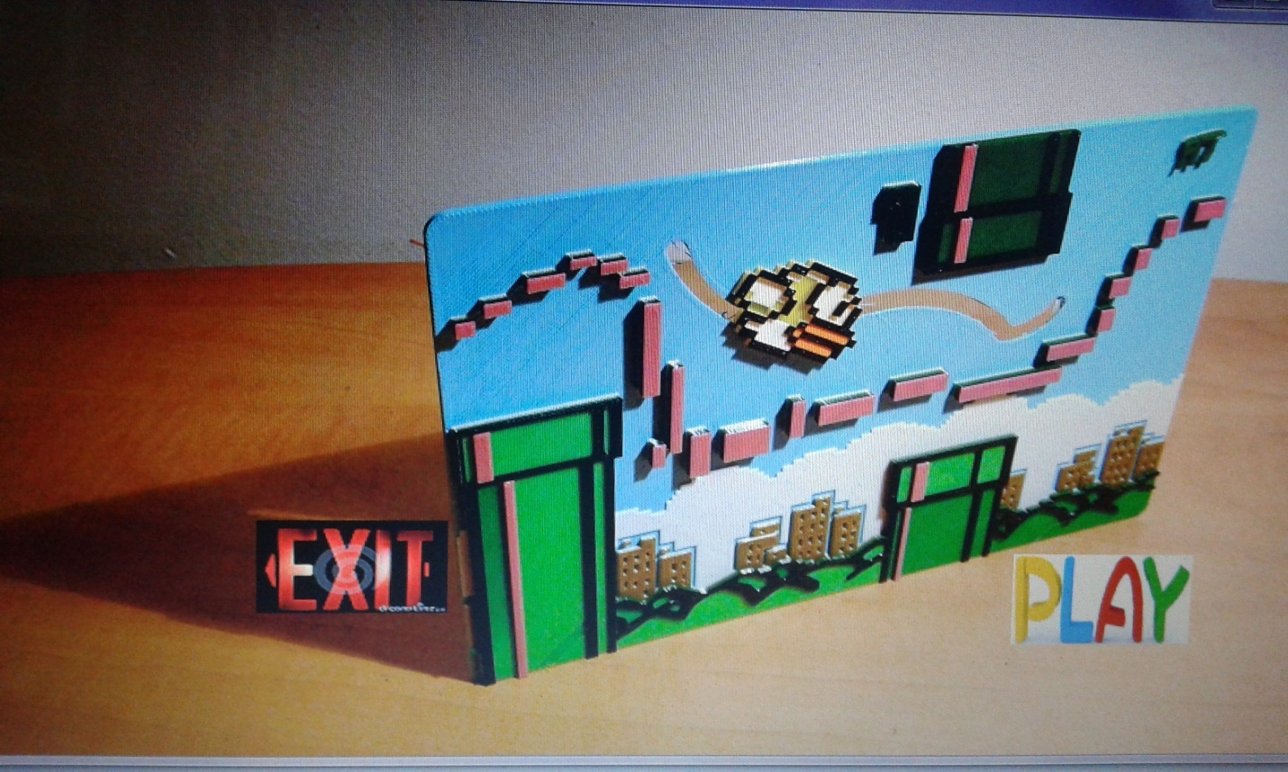

**Start menu**

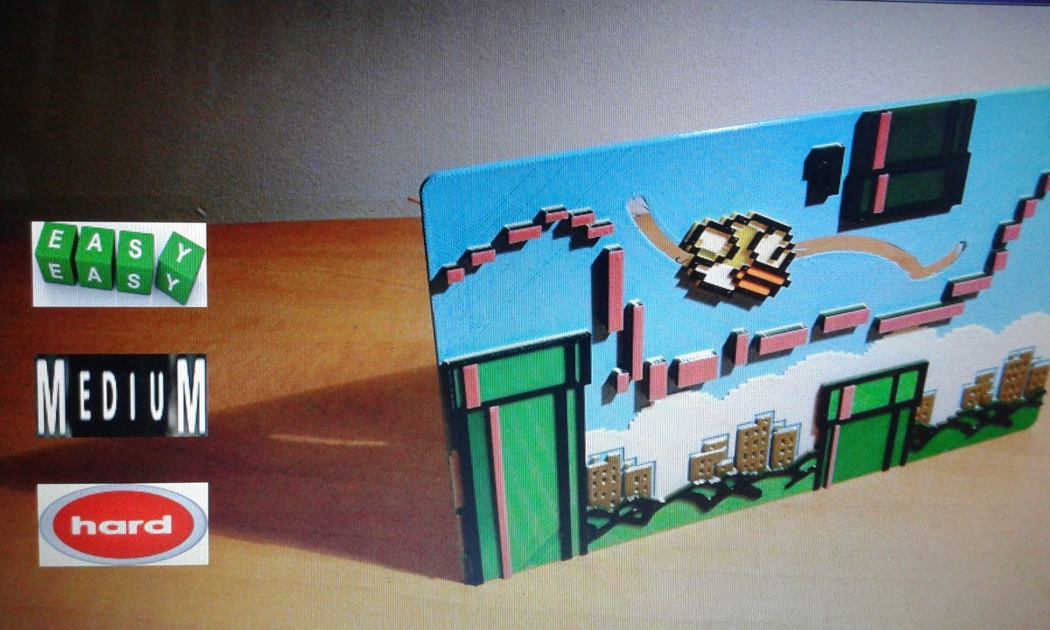

**Mode**

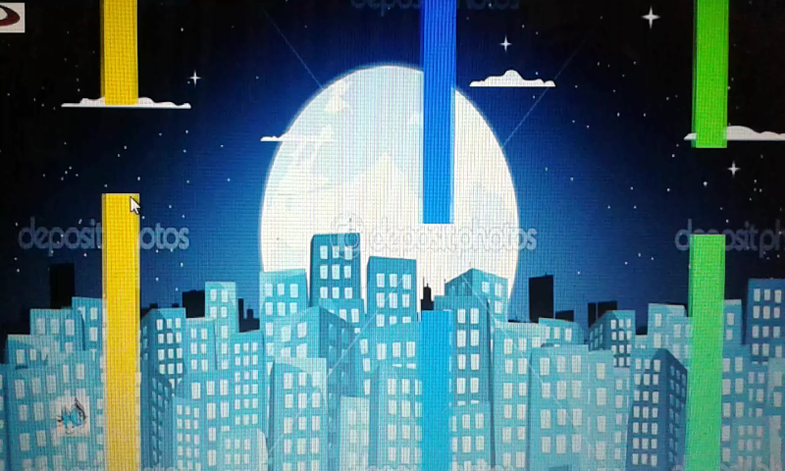

Easy mode

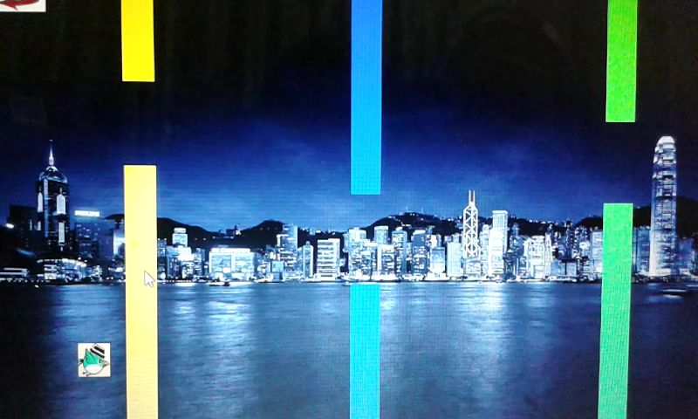

Medium mode

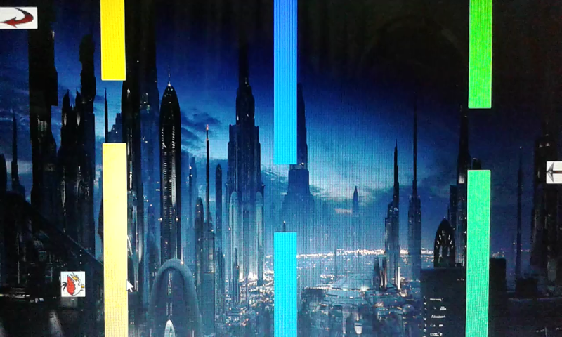

Hard mode

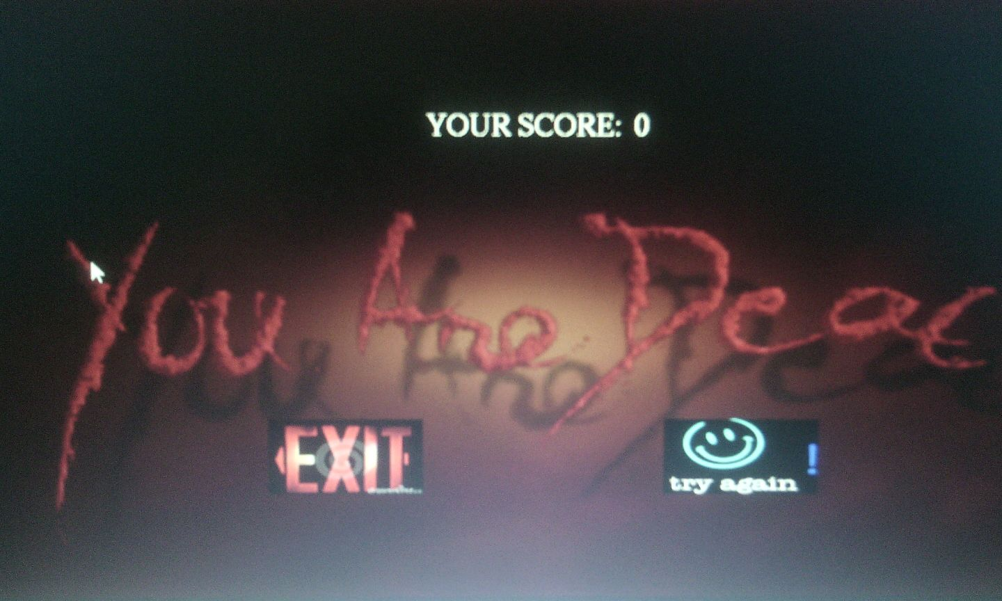

Game over

Learn:

1. As we face many challenges to do the project on igraphics , we learn many things from it.

2. We find some new functions while working and learn how they work. Suppose iSet timer.

3. We learn how to insert sound.

4. We learn how to measurement any object perfectly that can nicely presentable.

5. We can run a project and see the output of my coding instantly.

Benefits:

1. Can develop a better game then it.

2. Lots of good experience.

3. Got that inspiration that we can make more things.

4. Learn many new things that can be help in the future.